Cluster creation:

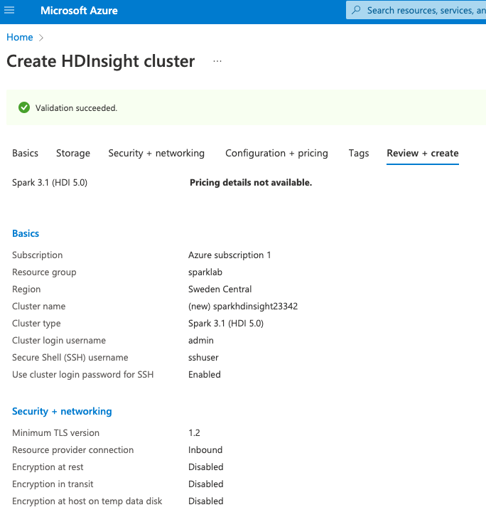

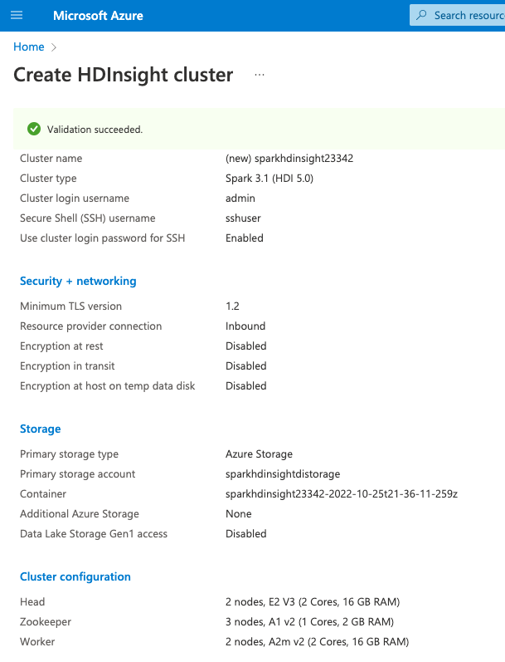

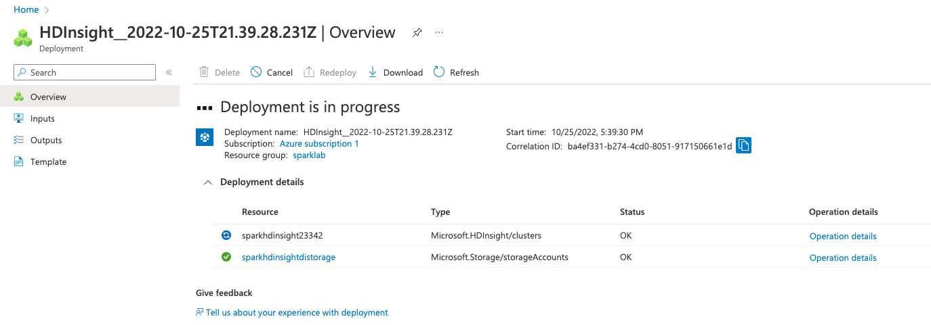

Deployment successful:

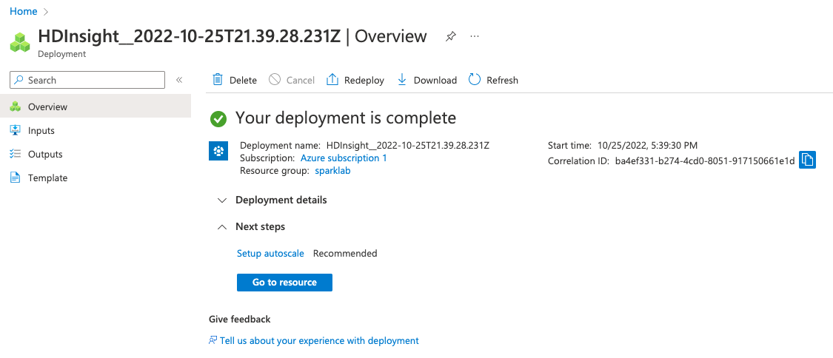

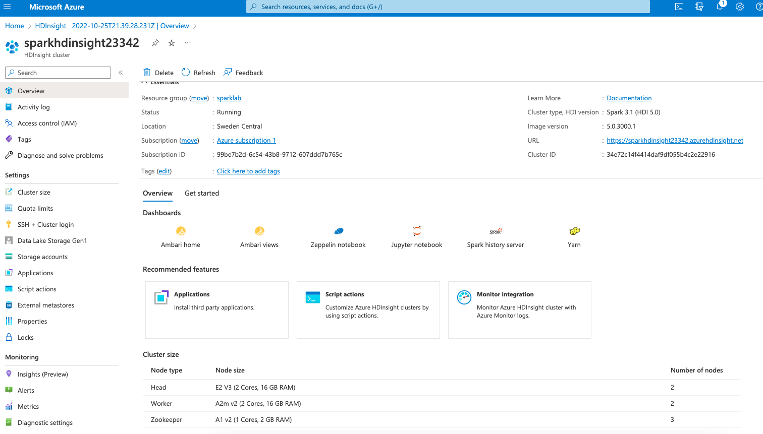

Uploading files

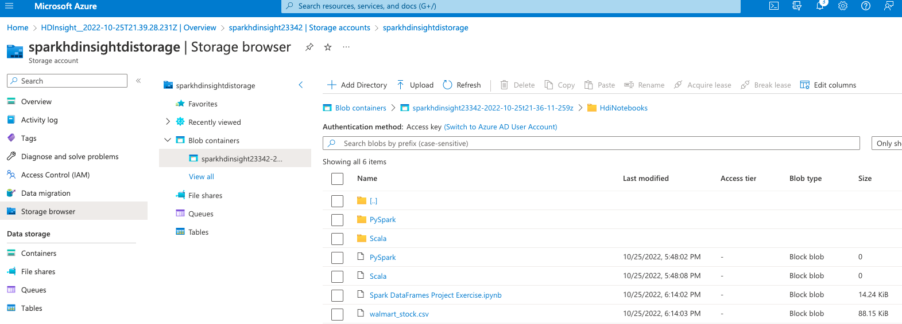

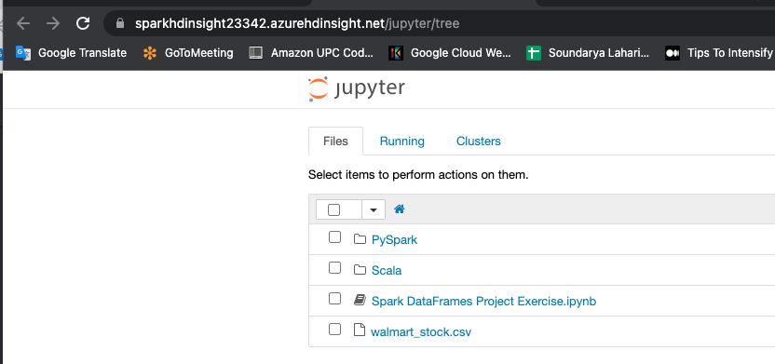

Deleting resource group to delete cluster

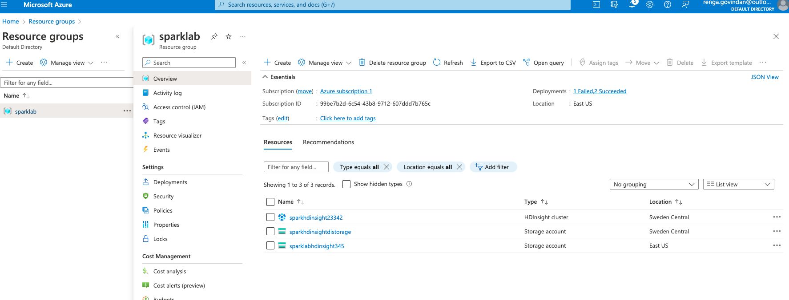

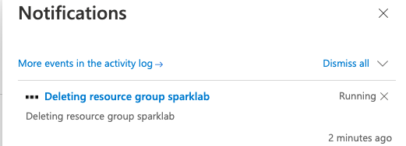

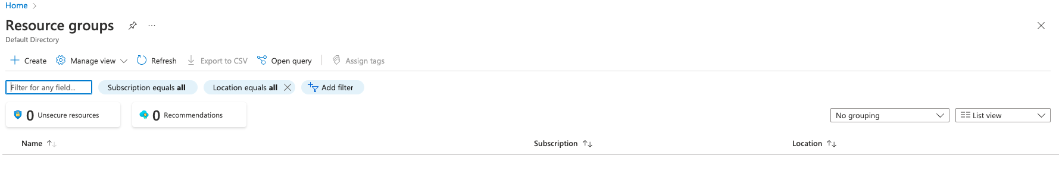

Errors seen when clusters were created:

Error: 'VM size 'standard_a1_v2' provided in the request is invalid or not supported for role 'headnode'. Valid values are: EXTRALARGE,LARGE,STANDARD_A4_V2,STANDARD_A4M_V2,STANDARD_A8_V2,STANDARD_A8M_V2,STANDARD_D12_V2,STANDARD_D13_V2,STANDARD_D14_V2,STANDARD_D3_V2,STANDARD_D4_V2,STANDARD_D5_V2,STANDARD_DS12_V2,STANDARD_DS13_V2,STANDARD_DS14_V2,STANDARD_DS3_V2,STANDARD_DS4_V2,STANDARD_DS5_V2,STANDARD_E16_V3,STANDARD_E16S_V3,STANDARD_E2_V3,STANDARD_E20_V3,STANDARD_E20S_V3,STANDARD_E2S_V3,STANDARD_E32_V3,STANDARD_E32S_V3,STANDARD_E4_V3,STANDARD_E4S_V3,STANDARD_E64_V3,STANDARD_E64I_V3,STANDARD_E64IS_V3,STANDARD_E64S_V3,STANDARD_E8_V3,STANDARD_E8S_V3'"

the validation. Error: 'VM size 'standard_a1_v2' provided in the request is invalid or not supported for role 'workernode'. Valid values are: EXTRALARGE,LARGE,STANDARD_A2M_V2,STANDARD_A4_V2,STANDARD_A4M_V2,STANDARD_A8_V2,STANDARD_A8M_V2,STANDARD_D12_V2,STANDARD_D13_V2,STANDARD_D14_V2,STANDARD_D3_V2,STANDARD_D4_V2,STANDARD_D5_V2,STANDARD_DS12_V2,STANDARD_DS13_V2,STANDARD_DS14_V2,STANDARD_DS3_V2,STANDARD_DS4_V2,STANDARD_DS5_V2,STANDARD_E16_V3,STANDARD_E16S_V3,STANDARD_E2_V3,STANDARD_E20_V3,STANDARD_E20S_V3,STANDARD_E2S_V3,STANDARD_E32_V3,STANDARD_E32S_V3,STANDARD_E4_V3,STANDARD_E4S_V3,STANDARD_E64_V3,STANDARD_E64I_V3,STANDARD_E64IS_V3,STANDARD_E64S_V3,STANDARD_E8_V3,STANDARD_E8S_V3,STANDARD_F16,STANDARD_F4,STANDARD_F8'"

x`